Beekman Painting Video Course
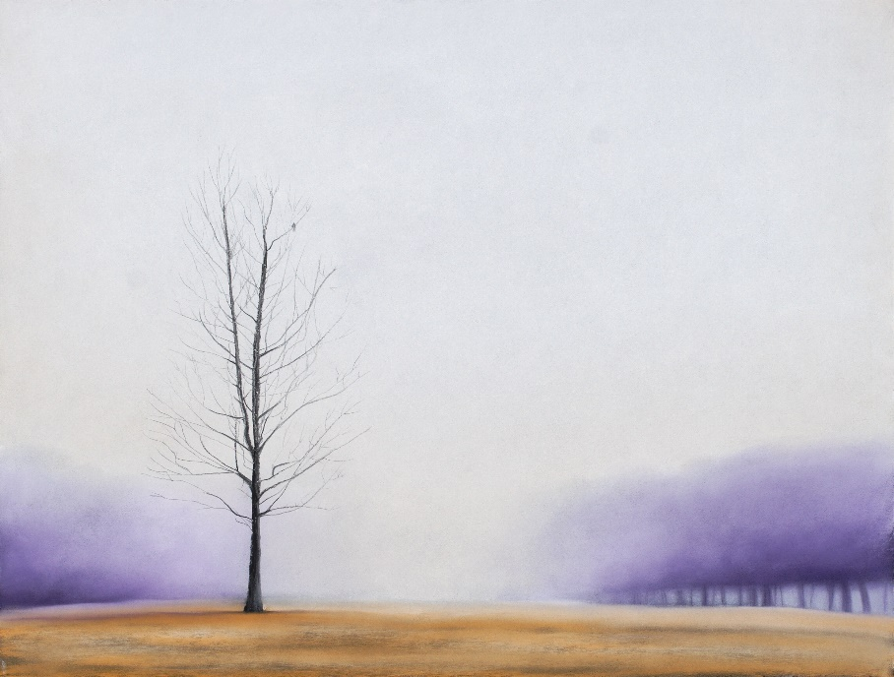
Together, we will paint this!

